**The purpose of the Project** : The main goal of project was detect original and fake banknotes using by photos of the banknotes.

**About data:** Dataset about distinguishing genuine and forged banknotes. Data were extracted from images that were taken from genuine and forged banknote-like specimens. For digitization, an industrial camera usually used for print inspection was used. The final images have 400x400 pixels. Due to the object lens and distance to the investigated object gray-scale pictures with a resolution of about 660 dpi were gained. A Wavelet Transform tool was used to extract features from these images.

**Methods :** A lot of methods for analyse data. We used following steps:

1. data exploration and pre-processing
2. modelling
3. evaluation
4. interpretation of the results.

In the first step I took right kind of datas, variance of Wavelet Transformed image, skewness of Wavelet Transformed image. First of all I did normalization, for this I used method where we calculated minimum and maximum numbers. Normalization help to us for train machine. Also calculated right kind of measures like, mean, standard deviation.

After calculating all measures we needed to create good model for our data, It is the heart of our research. I choose KMeans clustering algorithm for this part, beacause we need divide 2 cluster of this data, fake and original banknotes. The K-means clustering algorithm computes centroids and repeats until the optimal centroid is found. It is presumptively known how many clusters there are. It is also known as the flat clustering algorithm. The number of clusters found from data by the method is denoted by the letter ‘K’ in K-means.

In this method, data points are assigned to clusters in such a way that the sum of the squared distances between the data points and the centroid is as small as possible. It is essential to note that reduced diversity within clusters leads to more identical data points within the same cluster.

Next step is evaluation, after creating the model I check the model one more time. Found the center’s coordination. 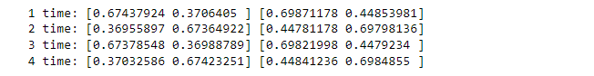

As you can see in the figure, there are different numbers. But the mean thing in the here is that difference of every different two points is not so high even tends to zero, it means the algorithm works very correct.

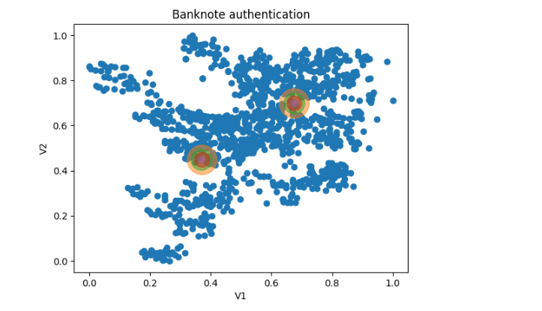**Result :** Finally the result of our analyzing.

Blue points are the given data, and other colors the centers. And using the centers we can detect information about banknotes are fake or no. The right top center is center of fake banknotes, we’ll calculate every distance from point to center and define the point is fake or no. If a point closer to fake center then, it means a point is fake.

**Recommendation :** For make sure that fact, the banknotes are really fake, and learn the machine correctly we need more data, the more data the more probability. That is why you should give more data, but this data is actually gives correct results, where accuracy is more than 89 %.